June 26, 2013

Allen Jones
Vice President of Sales
ABC
Via Email

Letter of Understanding

Dear Allen:

I appreciated our discussion on Monday. The purpose of this letter is to:
- Outline my understanding of the objectives you have in deploying a solution selling program (Table 1),
- Provide supporting documentation to show you how Adventace can help you fulfill those objectives, and
- Identify the Action Plan that I’d like to discuss with you to help you analyze Adventace and our capabilities (Table 2).

Please let me know when you will be available to discuss this document.

I hope your trip to China is going well!

Best regards,
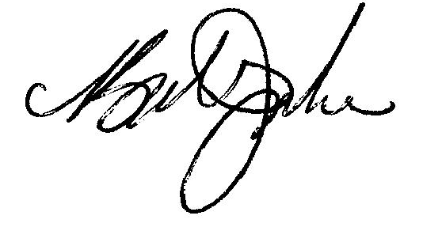
Robert W. Junke

Attachment

Table 1
Needs & Recommendations

Objective:

Help Your Team Tune/Improve Effectiveness by Reinvigorating Use of Solution Selling Methodology
Today’s Situation / Reason |  | Capability Required or Suggested by Bob | How Adventace® Can Help
1. | As time has passed, fewer people have been exposed to and/or use solution selling processes, which would positively impact performance. | Deploy a common solution selling methodology to get people back to the basics and a very strong foundation for highly effective performance. | See Appendix 2, Winning Major Opportunities (WMO), pages 7-8, of this document.
2. | Not developing value based on the need identified. | When developing the needs of buyers on opportunities:  - Identify the buyer’s critical business issue (CBI) along with the financial impact  - Diagnose the reasons, along with their financial impact, on the overall CBI  - Develop the set of capabilities the buyer needs to resolve their CBI’s, with ABC differentiators in mind  - Determine the value the capabilities bring to the buyer.  Subsequently, when building the Value Proposition for the ABC solution:  - Use the numbers identified from the need development process described above as the foundation for the ROI.  By following this process, sellers will ensure that individual buyers own the numbers and will take responsibility for achieving them. | See attached PPT, Winning Major Opportunities: Capabilities Review, pages 4-12 and 17-19
3. | There is a disconnect between the standard Vision Process and the Value Proposition. | Explicitly tie the above Value Proposition to the Vision Process. In this manner the buyers will better understand that the capabilities provided by ABC will not only help them resolve their CBI’s, but will bring significant financial value to them. In turn this will improve their confidence and desire to move forward with ABC. | Same as above: See attached PPT, Winning Major Opportunities: Capabilities Review, pages 4-12 and 17-19
4. | Sell cycles are too long, opportunities sometimes “go away”, or ABC doesn’t get the anticipated results. | Use an Action Plan providing buyers with a logical sequence of events to define and better manage, qualify, and control sell cycles. | See attached PPT, Winning Major Opportunities: Capabilities Review, pages 13-16
5. | What terminology has changed and what is the flow of the sales program? | The terminology should fit today’s selling situations. Further, there must be a logical flow to the sales program. | See attached PPT, Winning Major Opportunities: Capabilities Review, pages 21-23

Table 2
Suggested Action Plan
Objective | Date | Action Item | Go/No Go | Completed
Identify Needs | w/o 7/1 | Review Letter of Understanding & associated PowerPoint with Allen | *
 | TBD | Discussions with others whom Allen may identify
 | TBD | Discuss other potential skills which may be needed by Allen’s team (e.g., account penetration, buyer “power line” assessment, managing a buying committee, qualification, negotiating, closing)
 | TBD | Summarize findings to ABC | *
Proof and Due Diligence | TBD | Design program
 | TBD | Review program with Allen | *
 | TBD | Provide additional proof of Adventace® capabilities (method TBD) | *
 | TBD | Submit Agreement Letter
Approval | TBD | Approve Agreement Letter | *
Implementation | TBD | Conduct WMO training program

Appendix 1
About Adventace®

We are a global sales and sales management consulting firm whose promise is to help our clients Create the High Performance Sales Environment®. To fulfill that promise we bring the Adventace 1-2-3 System™, “glocal” capabilities, industry leadership, and metric-based client results.

Adventace 1-2-3 System®
The Adventace 1-2-3 System™ is comprised of our:
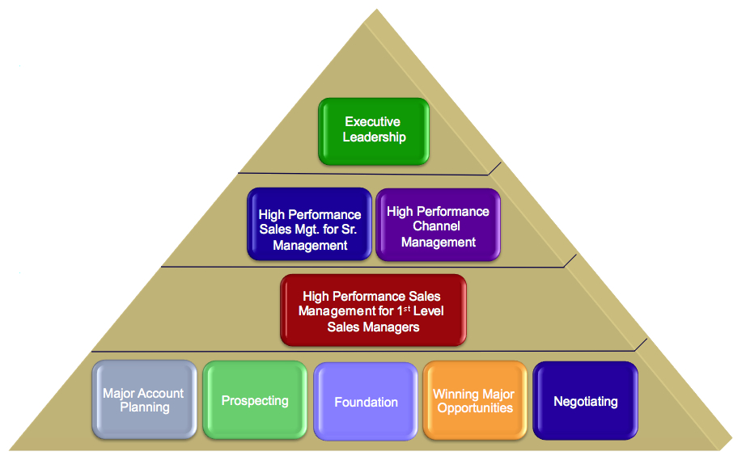
- Holistic Methodology: Our methodology consists of highly targeted programs for sales executives, sales managers, channel managers, and sellers. It provides processes, tools, and a knowledge repository integrated into a holistic methodology. It is designed to help Sales Executives better drive the operation top-down, to help sales managers better coach and develop their sales people, manage pipelines and forecast, and to help sellers align with and sell more effectively to their buyers. A key component of the methodology, Winning Major Opportunities (WMO), is our flagship solution selling program.

The methodology has evolved significantly over the past two decades to become very broad and deep. This represents great advantage to our clients when it comes to program design. Based on their requirements we are able to rapidly “pull together” highly customized training programs.

- CRM Application. Through partnership with Salesforce.com, we have integrated and automated our entire methodology into the Adventace® Sales Management System (SMS). This application is a complete, top-to-bottom sales management system. For more information please select Adventace SMS™.
- Change Management Services. We view Change Management as a structured approach to help individuals, teams, and the organization transition from their current state to a desired future state. Change for most people is quite difficult, whether it is at the personal or organizational level. People must change bad habits, adapt to better procedures in the field, and even dramatically change the ways they deal with buyers. Our change management processes are proven to rapidly and successfully help organizations effectively manage their transition and achieve metric based results for the long term.

“Glocal” Delivery
“Glocal” simply means that we specialize in the global delivery of our services through a network of locally based instructors. In fact, we now deliver in 11 languages through a network of 40+ facilitators.
Our instructors average 25+ years of experience. Over 90% have very strong direct experience in:
- Complex, multi-product solution sales
- Consulting
- Sales management.
Many of our instructors have held CXO positions.

We believe that local facilitation is an essential success ingredient. Locally based instructors are able to better communicate with students. They are also quite capable of making the adaptations necessary based on the local culture. This also minimizes the costs to our clients.

Industry Leadership
Our vision is to be recognized as one of the world’s preeminent sales and sales management consulting firms based on the measurable impact we have on our clients. Providing our comprehensive and innovative intellectual property is a key facet of that vision.

We also strive to “move the industry forward” as a preeminent thought leader. Consequently, we provide our clients with information that will positively impact them on a daily basis. This information is provided primarily through our blog and video channel.

Metric-Based Client Success
Through the Adventace 1-2-3 System™, our clients have historically outperformed past results by a factor of at least 2:1. A summary of the results of just a few of our clients is provided below.
- SolidWorks: Achieved up to a 647% performance improvement.
- SunGard: Previously a $1M deal was considered large. In one quarter in one region they closed 3-$10M deals and 1-$20M deal. Also, deals that would have taken six months or more to close, closed in 3-6 weeks
- TransUnion increased their win size by 15% while successfully driving multi-million dollar engagements.
For more information please see clients.

Appendix 2
Winning Major Opportunities (WMO)

Background
Winning Major Opportunities is Adventace’s advanced solution selling program. It represents the “next generation” in the evolution of solution selling.

In the 1990’s, while affiliated with the Solution Selling organization, Bob Junke, Founder & CEO of Adventace, was responsible for upgrading that generation’s program from a “product sale focus” to one that integrated consulting, services, and systems integration. Those efforts resulted in Bob being awarded part ownership of Solution Selling. With the launch of Adventace® in 2001, Bob set out to create the “next generation” solution selling program.

What Differentiates Winning Major Opportunities?
Our Winning Major Opportunities program provides:
- Processes that are much easier to learn and execute in the field
- Many enhanced processes, such as:
  - Opportunity Identification on key accounts, to help Account Executives be “first in” on major opportunities
  - The Four Quadrants of lead generation/prospecting
  - Social networking: Generating leads and integration with prospecting
  - Advanced need development processes, including:
    - Solution Evolution
    - Solution Re-Evolution
    - How to conduct highly effective “B2B” conversations and “funnel” the buyer to identify and discuss their Critical Business Issue
    - Determining the financial impact of the Critical Business Issue
    - Determining the financial benefit of each capability
    - Identifying metrics to track success
    - Determining the buyer’s “emotional quotient”: Their desire to move forward with change
  - Building a ROI based on the financial impact and benefits identified in need development
  - How to ensure that individual buyers - not the seller - take responsibility for achieving financial results, making “buy in” to the ROI successful
- Unique opportunity management processes that include:
  - Opportunity assessment to determine competitive strengths and weaknesses, and how to neutralize weaknesses
  - Identifying and scoring all key buyers’ Preferences toward you Vs. the competition, and how to improve the preferences of buyers you are “at risk” with
  - Based on six options, how to identify and pursue the Strategy you should follow
  - Resource management to identify the people needed to support the sales effort and the timing of their need so that the right people are available at the right time.
  - Use of a Management Opportunity Review (MORE) process that has proven ability to dramatically improve close rates.

Impact on Your Investment
Because of process improvements we are able to conduct a WMO workshop at an average cost of 38% less than previous generation solution selling workshops. For example, in the past solution selling workshops required an instructor, instructor’s assistant, and coaches at a ratio of 1 coach for every 3 participants. By streamlining key sales processes and making them more intuitive, we have eliminated the needed for coaches.

We are also able to reduce participant time out of the field by a minimum 25%.

Attendee Comments
Provided below are comments from sales people and sales managers who attended recent WMO programs:
In the past we considered a $1M deal to be large. Now, in one quarter in one region we closed 3-$10M deals and 1-$20M deal.
The Monday after the workshop I built an Impact Tree™ with a group of buyers that totally turned a $25M opportunity that we thought we had lost.
Our largest contract award size nearly quadrupled, average contract size nearly doubled, 78% of my sellers achieved quota, new license sales grew by 91%, and we finished the first quarter of our new fiscal year at 143% of plan.
My sellers are now comfortable calling two levels higher.
Very well done! This will significantly impact my close ratio with major accounts.
Very rarely do you attend training and have the ability to use it the next day. I discovered several actionable things I can do immediately.
The assessment piece will help me manage and control major account opportunities...for real!
Very helpful. I will apply the principles across all opportunities, not just those from major accounts.
The material provides a very clear and organized process to navigate the complex sale.
A very good method of how large opportunities need to be proactively managed and provides the tools we need to use daily.

